Introduce Graphics to the blind – one pixel at a time
We hope our pitch does not seem too much like an Electrical Engineering 6.01 course promotion.
During the last few years, we have been introducing computer programming to beginners. My target audience is the young or old who have “missed the boat” to learning programming. We are not looking for fired-up folks who would absorb the topic with little or no outside help. We have noticed that often our students find our programming examples lacking in excitement. After gaining appreciation for the power of programming, appreciation for abstraction comes easier. After thought, we settled on the idea of including simple graphics. For example, we provided the following simple program, which draws a square.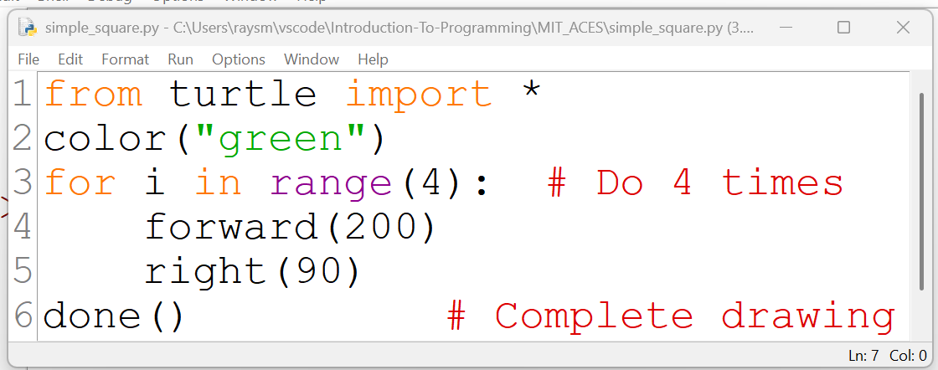
We run this example program, producing the following: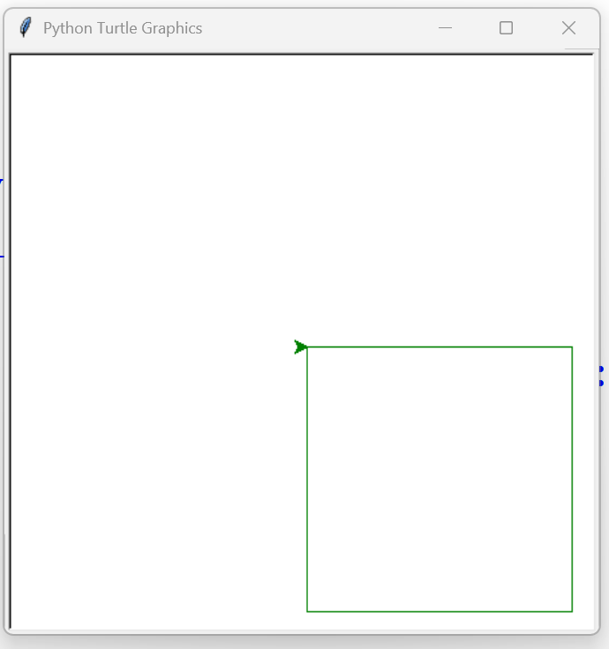
We modified the program slightly to change the square’s color to red.
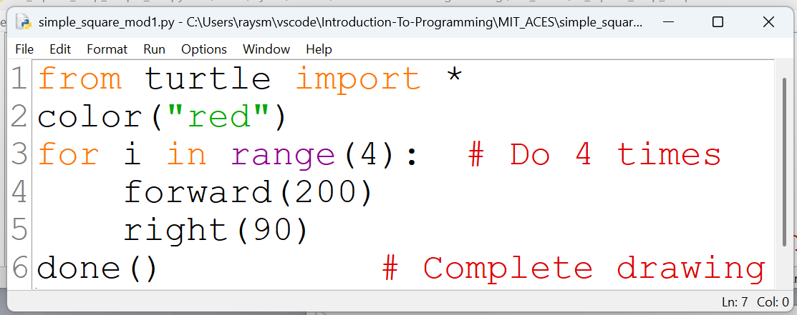
Running the modified program, we see the following results.
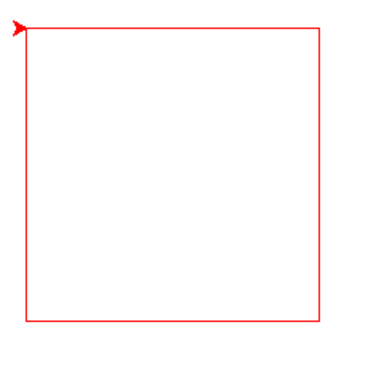
Exercises like the one above appear to help.
We were feeling good for a time. Sadly, it occurred to us, that this type of graphical example would be much less exciting to the blind student. After considerable thought, we came upon the following plan.
The Plan
Modify the underlining(hidden) software so that running the original program or something remarkably similar produces output that the blind user could “see”.
When running a program, using our modified software, a text map of the figure is generated. This text map, when sent to a Braille embosser, provides a physical version of the figure. Understandably, Braille is coarser, with less resolution, than the original picture, but it is touchable.

New Code, with only a minor change(“turtle” to “turtle_braille_link”) from the standard code:
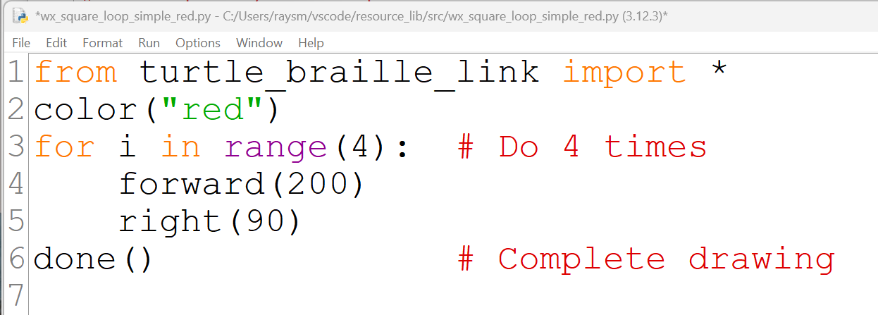
Text map produced:
File: wx_square_loop_simple_red.py Date: 2025-07-15 20:57 User: Owner

,,rrrrrrrrrrr
,,rr,,,,,,,,r
,,rr,,,,,,,,r
,,rr,,,,,,,,r
,,rr,,,,,,,,r
,,rr,,,,,,,,r
,,rrrrrrrrrrr

We use commas(,) for multiple non-trailing spaces to mitigate the fact that the Braille embossing software compresses multiple spaces. The Braille for comma is a single dot so it appears “space” like.
Below is a graphical portrayal of Braille produced from the above text map. Since there is no embossing software involved here, we omit the commas.
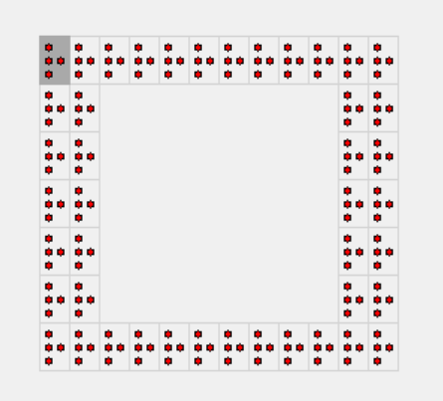
Although not mentioned above, we have added audio presentation options.

The pitch
Our tool, though functional, is just a prototype. We could use lots of help. We would appreciate any ideas, reviewing, testing, or coding suggestions from all interested parties. We are available to give demonstrations and further description.

